Dustin Kendall

kendalld@pnw.edu

Lab 1   
Combinational Logic

Instructor: Quamar Niyaz

# Schematics

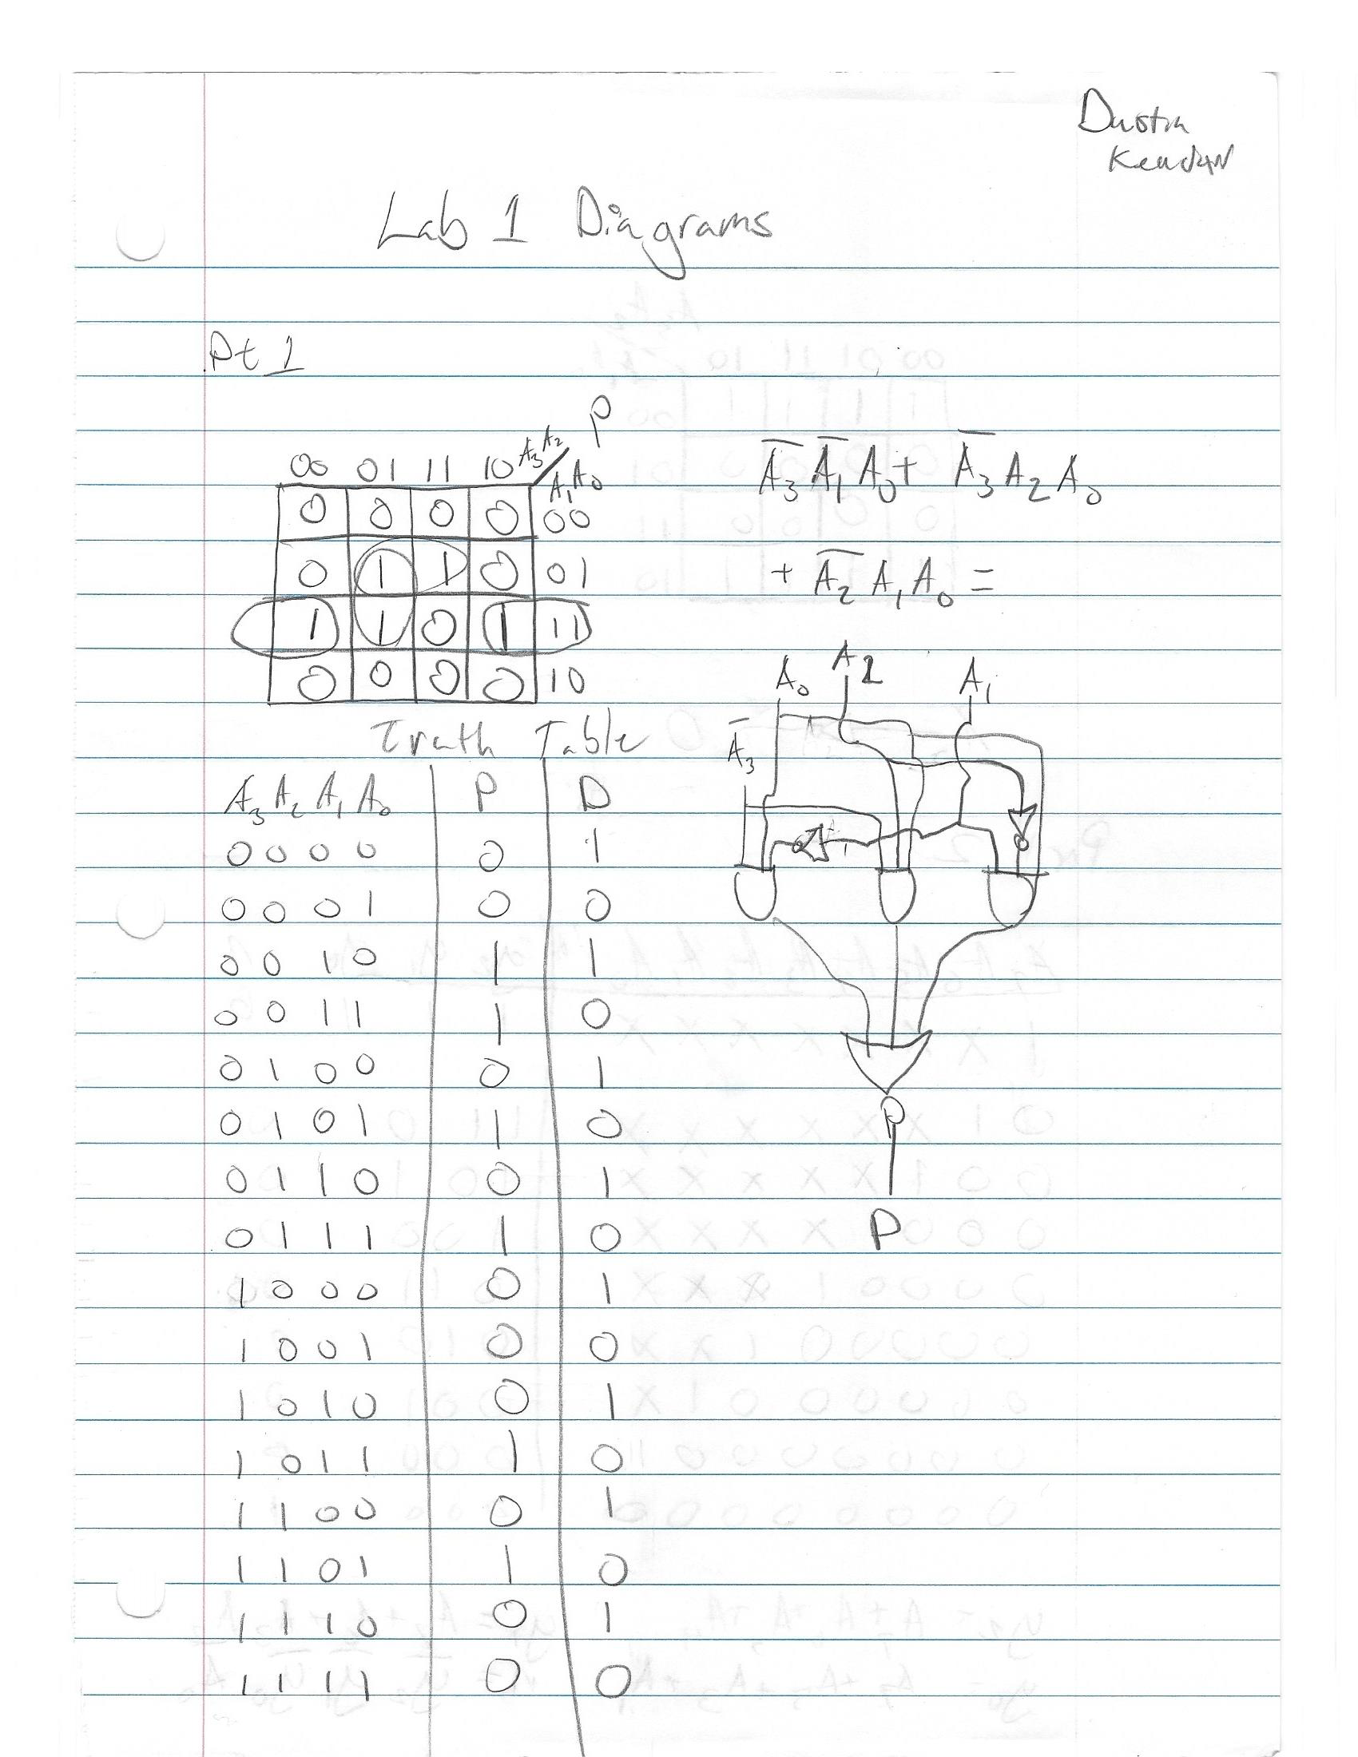

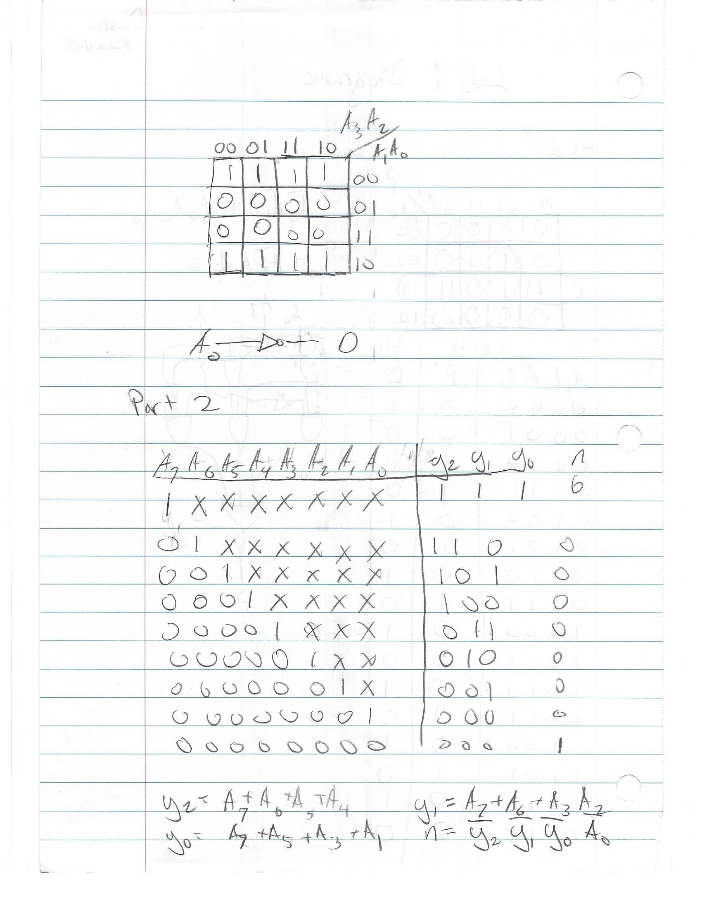

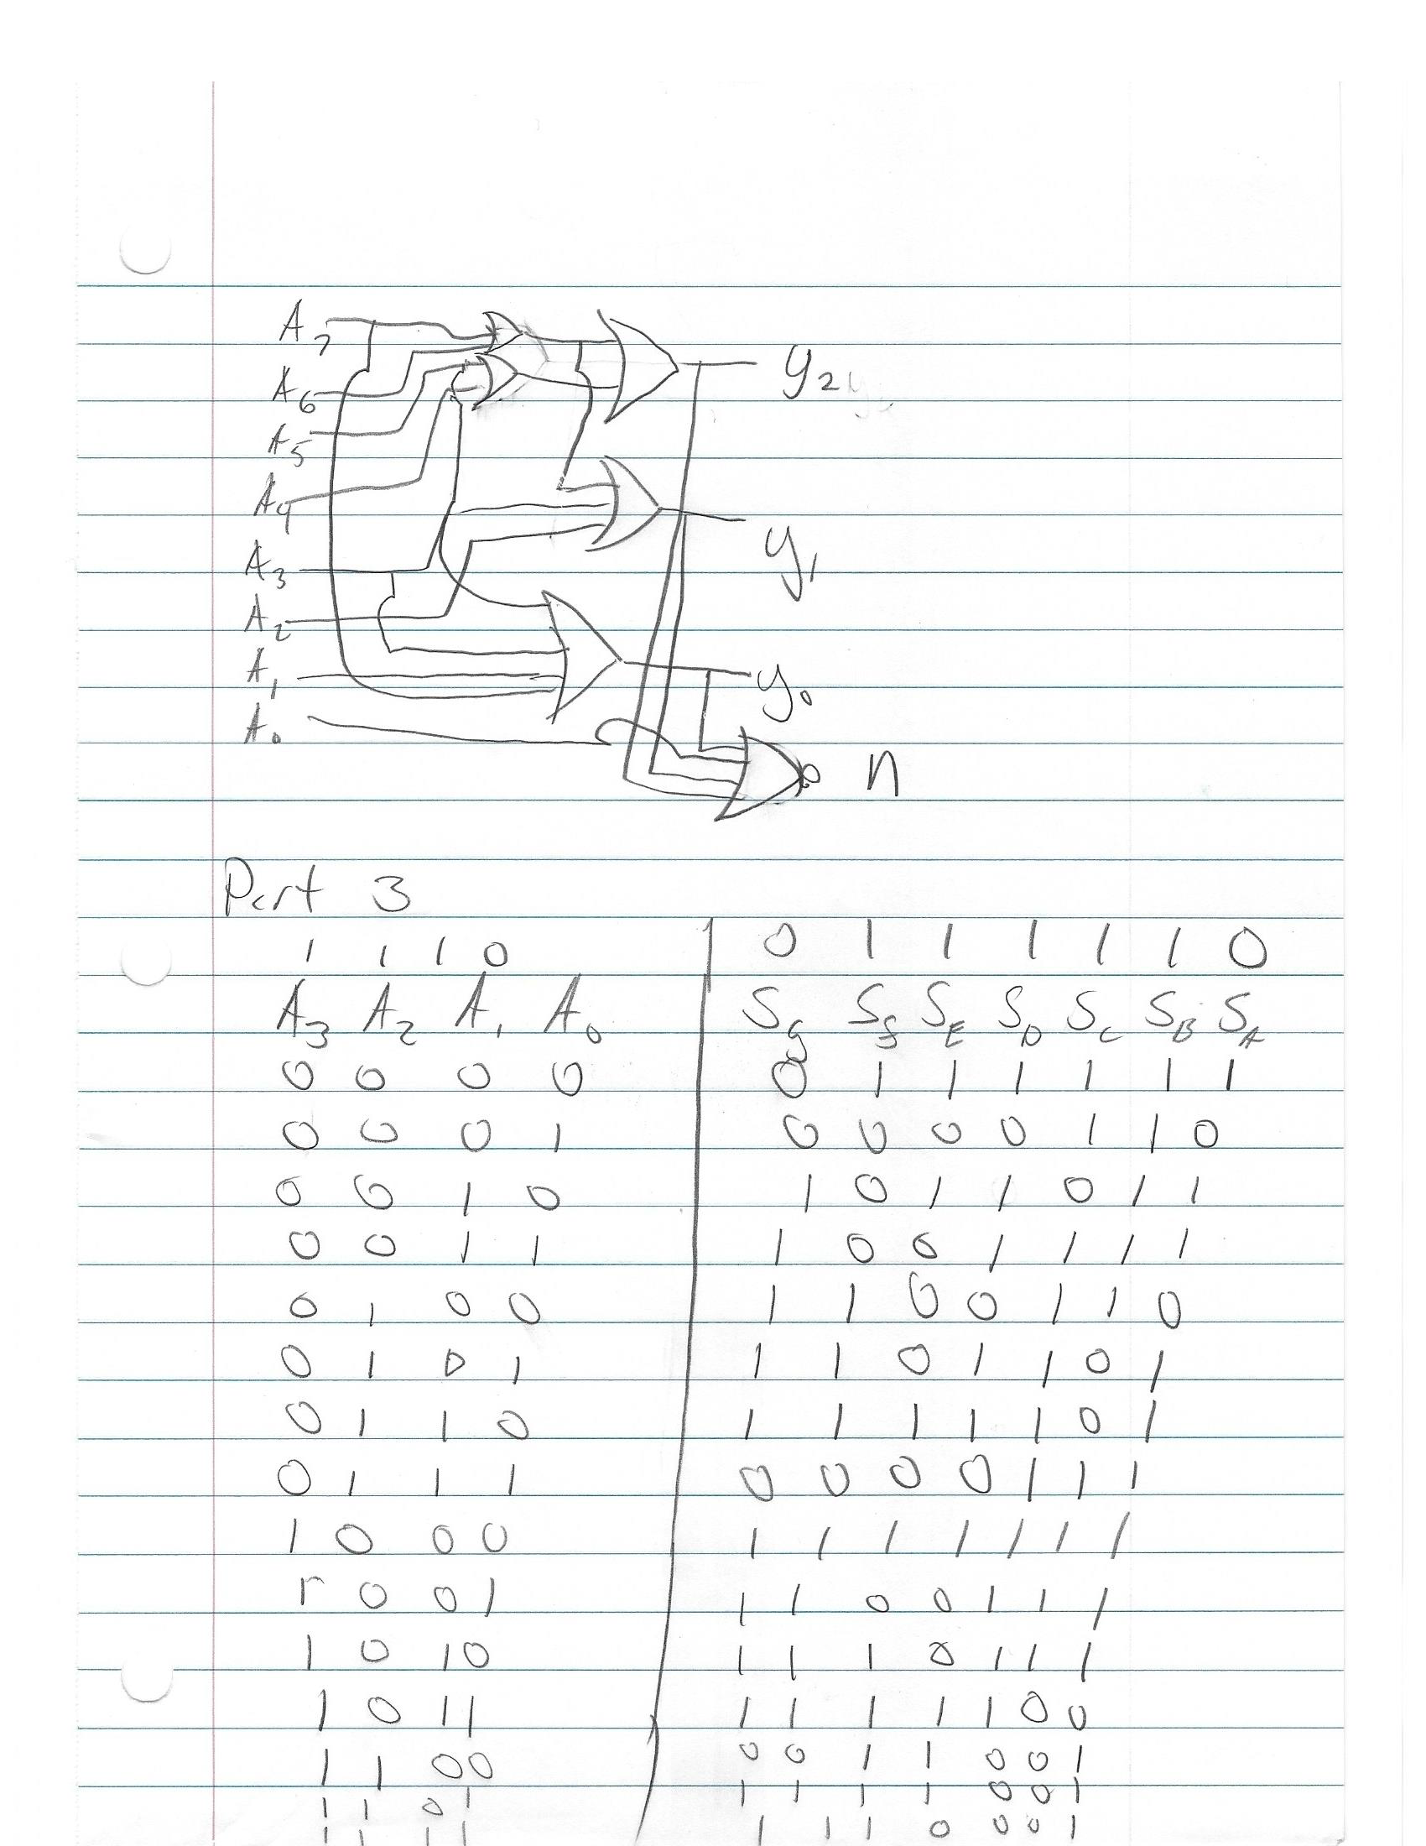

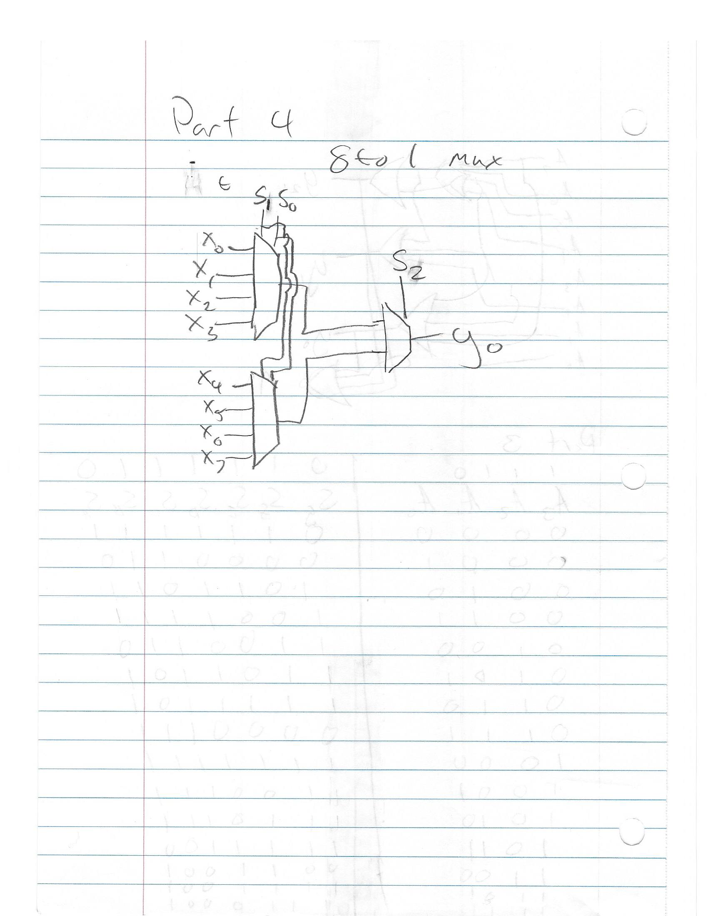

## Part 1

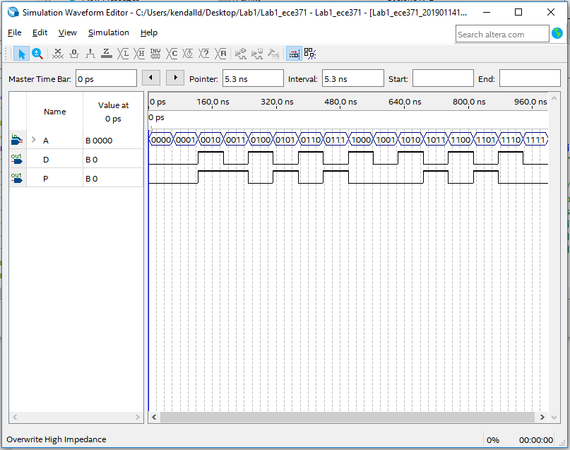

### Files



## Part 2

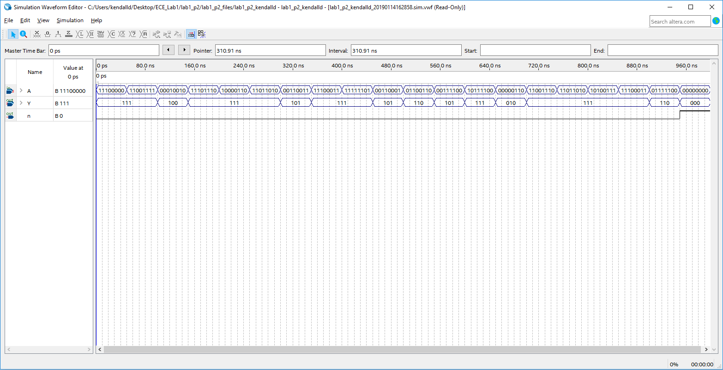

### Files



## Part 3

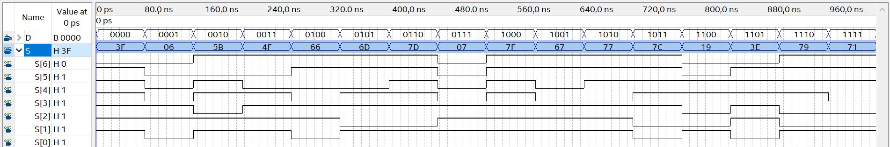

### Files



## Part 4

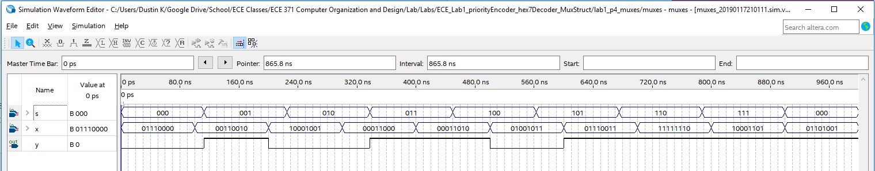

### Files

